SHOULDER YAW

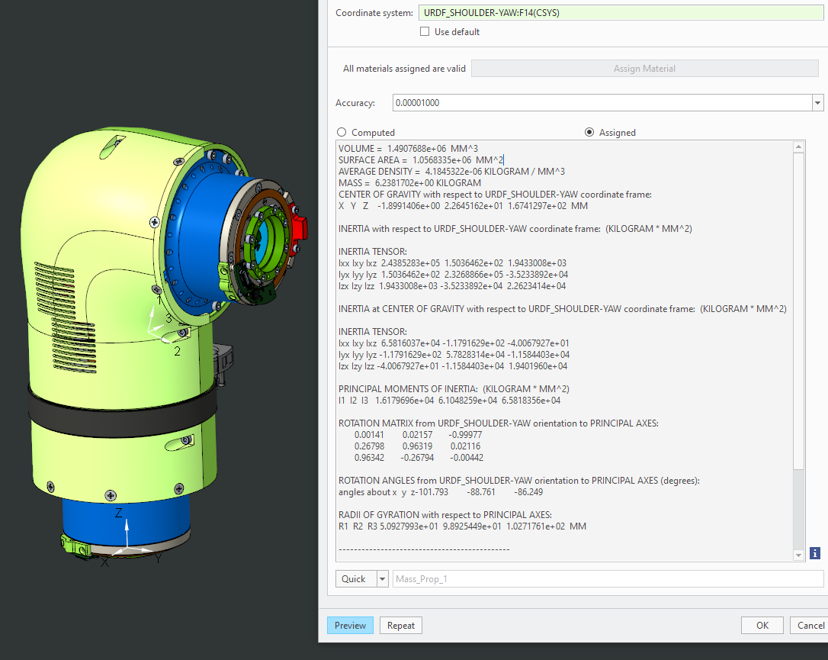

VOLUME = 1.4907688e+06 MM^3

SURFACE AREA = 1.0568335e+06 MM^2

AVERAGE DENSITY = 4.1845322e-06 KILOGRAM / MM^3

MASS = 6.2381702e+00 KILOGRAM

CENTER OF GRAVITY with respect to URDF_SHOULDER-YAW coordinate frame:

X Y Z -1.8991406e+00 2.2645162e+01 1.6741297e+02 MM

INERTIA with respect to URDF_SHOULDER-YAW coordinate frame: (KILOGRAM * MM^2)

INERTIA TENSOR:

Ixx Ixy Ixz 2.4385283e+05 1.5036462e+02 1.9433008e+03

Iyx Iyy Iyz 1.5036462e+02 2.3268866e+05 -3.5233892e+04

Izx Izy Izz 1.9433008e+03 -3.5233892e+04 2.2623414e+04

INERTIA at CENTER OF GRAVITY with respect to URDF_SHOULDER-YAW coordinate frame: (KILOGRAM * MM^2)

INERTIA TENSOR:

Ixx Ixy Ixz 6.5816037e+04 -1.1791629e+02 -4.0067927e+01

Iyx Iyy Iyz -1.1791629e+02 5.7828314e+04 -1.1584403e+04

Izx Izy Izz -4.0067927e+01 -1.1584403e+04 1.9401960e+04

PRINCIPAL MOMENTS OF INERTIA: (KILOGRAM * MM^2)

I1 I2 I3 1.6179696e+04 6.1048259e+04 6.5818356e+04

ROTATION MATRIX from URDF_SHOULDER-YAW orientation to PRINCIPAL AXES:

0.00141 0.02157 -0.99977

0.26798 0.96319 0.02116

0.96342 -0.26794 -0.00442

ROTATION ANGLES from URDF_SHOULDER-YAW orientation to PRINCIPAL AXES (degrees):

angles about x y z-101.793 -88.761 -86.249

RADII OF GYRATION with respect to PRINCIPAL AXES:

R1 R2 R3 5.0927993e+01 9.8925449e+01 1.0271761e+02 MM

SHOULDER PITCH

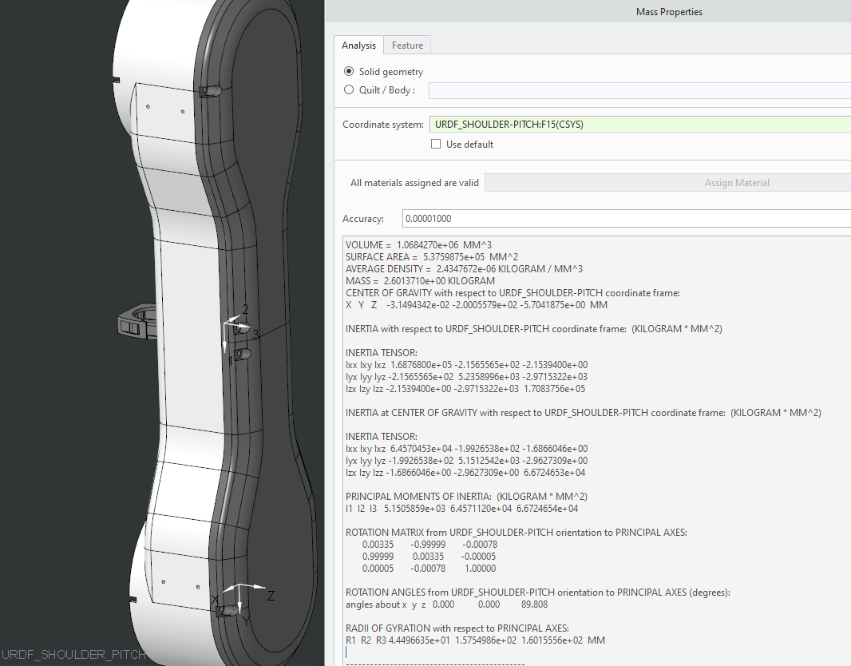

VOLUME = 1.0684270e+06 MM^3

SURFACE AREA = 5.3759875e+05 MM^2

AVERAGE DENSITY = 2.4347672e-06 KILOGRAM / MM^3

MASS = 2.6013710e+00 KILOGRAM

CENTER OF GRAVITY with respect to URDF_SHOULDER-PITCH coordinate frame:

X Y Z -3.1494342e-02 -2.0005579e+02 -5.7041875e+00 MM

INERTIA with respect to URDF_SHOULDER-PITCH coordinate frame: (KILOGRAM * MM^2)

INERTIA TENSOR:

Ixx Ixy Ixz 1.6876800e+05 -2.1565565e+02 -2.1539400e+00

Iyx Iyy Iyz -2.1565565e+02 5.2358996e+03 -2.9715322e+03

Izx Izy Izz -2.1539400e+00 -2.9715322e+03 1.7083756e+05

INERTIA at CENTER OF GRAVITY with respect to URDF_SHOULDER-PITCH coordinate frame: (KILOGRAM * MM^2)

INERTIA TENSOR:

Ixx Ixy Ixz 6.4570453e+04 -1.9926538e+02 -1.6866046e+00

Iyx Iyy Iyz -1.9926538e+02 5.1512542e+03 -2.9627309e+00

Izx Izy Izz -1.6866046e+00 -2.9627309e+00 6.6724653e+04

PRINCIPAL MOMENTS OF INERTIA: (KILOGRAM * MM^2)

I1 I2 I3 5.1505859e+03 6.4571120e+04 6.6724654e+04

ROTATION MATRIX from URDF_SHOULDER-PITCH orientation to PRINCIPAL AXES:

0.00335 -0.99999 -0.00078

0.99999 0.00335 -0.00005

0.00005 -0.00078 1.00000

ROTATION ANGLES from URDF_SHOULDER-PITCH orientation to PRINCIPAL AXES (degrees):

angles about x y z 0.000 0.000 89.808

RADII OF GYRATION with respect to PRINCIPAL AXES:

R1 R2 R3 4.4496635e+01 1.5754986e+02 1.6015556e+02 MM

---------------------------------------------

ELBOW

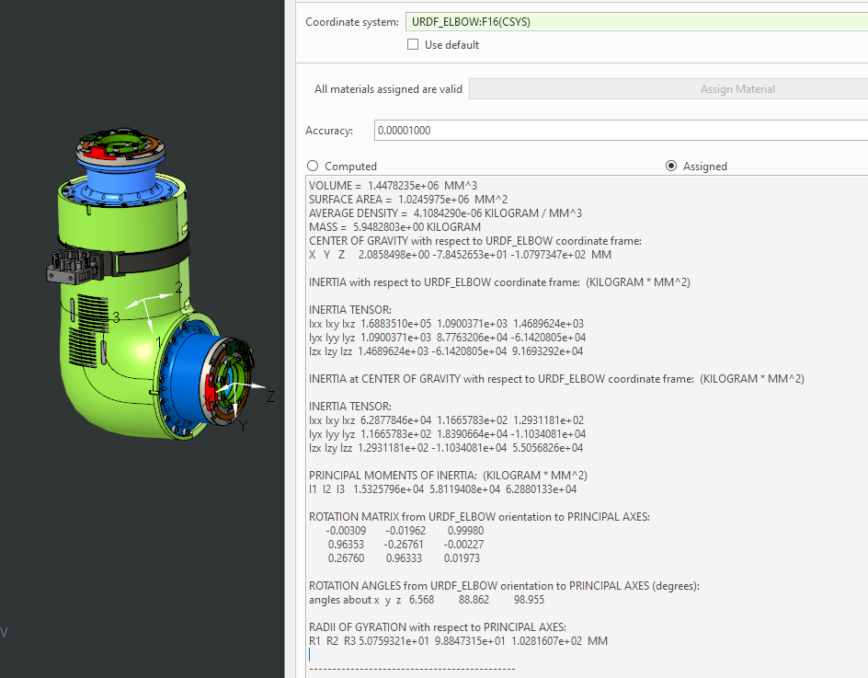

VOLUME = 1.4478235e+06 MM^3

SURFACE AREA = 1.0245975e+06 MM^2

AVERAGE DENSITY = 4.1084290e-06 KILOGRAM / MM^3

MASS = 5.9482803e+00 KILOGRAM

CENTER OF GRAVITY with respect to URDF_ELBOW coordinate frame:

X Y Z 2.0858498e+00 -7.8452653e+01 -1.0797347e+02 MM

INERTIA with respect to URDF_ELBOW coordinate frame: (KILOGRAM * MM^2)

INERTIA TENSOR:

Ixx Ixy Ixz 1.6883510e+05 1.0900371e+03 1.4689624e+03

Iyx Iyy Iyz 1.0900371e+03 8.7763206e+04 -6.1420805e+04

Izx Izy Izz 1.4689624e+03 -6.1420805e+04 9.1693292e+04

INERTIA at CENTER OF GRAVITY with respect to URDF_ELBOW coordinate frame: (KILOGRAM * MM^2)

INERTIA TENSOR:

Ixx Ixy Ixz 6.2877846e+04 1.1665783e+02 1.2931181e+02

Iyx Iyy Iyz 1.1665783e+02 1.8390664e+04 -1.1034081e+04

Izx Izy Izz 1.2931181e+02 -1.1034081e+04 5.5056826e+04

PRINCIPAL MOMENTS OF INERTIA: (KILOGRAM * MM^2)

I1 I2 I3 1.5325796e+04 5.8119408e+04 6.2880133e+04

ROTATION MATRIX from URDF_ELBOW orientation to PRINCIPAL AXES:

-0.00309 -0.01962 0.99980

0.96353 -0.26761 -0.00227

0.26760 0.96333 0.01973

ROTATION ANGLES from URDF_ELBOW orientation to PRINCIPAL AXES (degrees):

angles about x y z 6.568 88.862 98.955

RADII OF GYRATION with respect to PRINCIPAL AXES:

R1 R2 R3 5.0759321e+01 9.8847315e+01 1.0281607e+02 MM

---------------------------------------------

FOREARM-YAW

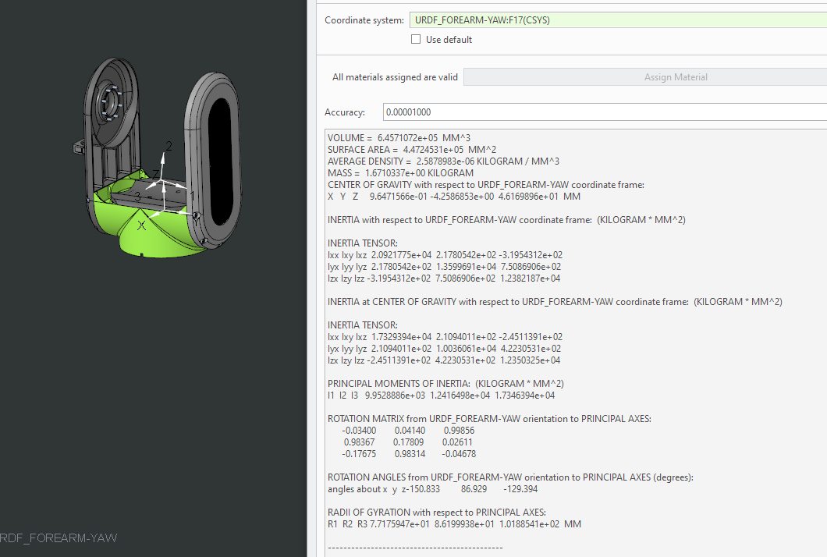

VOLUME = 6.4571072e+05 MM^3

SURFACE AREA = 4.4724531e+05 MM^2

AVERAGE DENSITY = 2.5878983e-06 KILOGRAM / MM^3

MASS = 1.6710337e+00 KILOGRAM

CENTER OF GRAVITY with respect to URDF_FOREARM-YAW coordinate frame:

X Y Z 9.6471566e-01 -4.2586853e+00 4.6169896e+01 MM

INERTIA with respect to URDF_FOREARM-YAW coordinate frame: (KILOGRAM * MM^2)

INERTIA TENSOR:

Ixx Ixy Ixz 2.0921775e+04 2.1780542e+02 -3.1954312e+02

Iyx Iyy Iyz 2.1780542e+02 1.3599691e+04 7.5086906e+02

Izx Izy Izz -3.1954312e+02 7.5086906e+02 1.2382187e+04

INERTIA at CENTER OF GRAVITY with respect to URDF_FOREARM-YAW coordinate frame: (KILOGRAM * MM^2)

INERTIA TENSOR:

Ixx Ixy Ixz 1.7329394e+04 2.1094011e+02 -2.4511391e+02

Iyx Iyy Iyz 2.1094011e+02 1.0036061e+04 4.2230531e+02

Izx Izy Izz -2.4511391e+02 4.2230531e+02 1.2350325e+04

PRINCIPAL MOMENTS OF INERTIA: (KILOGRAM * MM^2)

I1 I2 I3 9.9528886e+03 1.2416498e+04 1.7346394e+04

ROTATION MATRIX from URDF_FOREARM-YAW orientation to PRINCIPAL AXES:

-0.03400 0.04140 0.99856

0.98367 0.17809 0.02611

-0.17675 0.98314 -0.04678

ROTATION ANGLES from URDF_FOREARM-YAW orientation to PRINCIPAL AXES (degrees):

angles about x y z-150.833 86.929 -129.394

RADII OF GYRATION with respect to PRINCIPAL AXES:

R1 R2 R3 7.7175947e+01 8.6199938e+01 1.0188541e+02 MM

---------------------------------------------

WRIST-PITCH

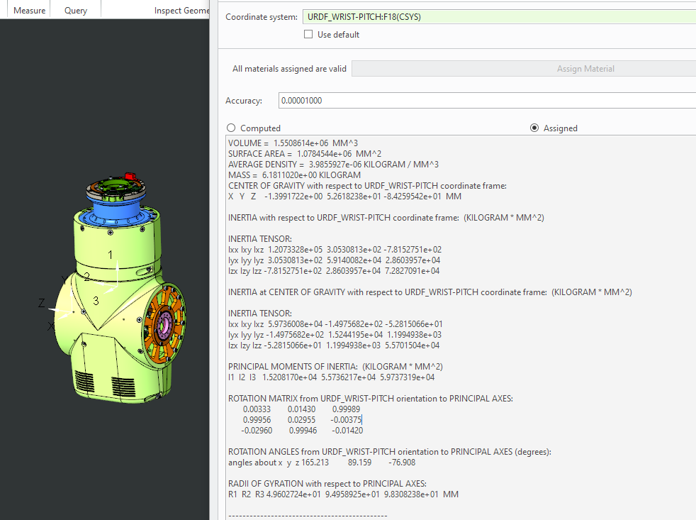

VOLUME = 1.5508614e+06 MM^3

SURFACE AREA = 1.0784544e+06 MM^2

AVERAGE DENSITY = 3.9855927e-06 KILOGRAM / MM^3

MASS = 6.1811020e+00 KILOGRAM

CENTER OF GRAVITY with respect to URDF_WRIST-PITCH coordinate frame:

X Y Z -1.3991722e+00 5.2618238e+01 -8.4259542e+01 MM

INERTIA with respect to URDF_WRIST-PITCH coordinate frame: (KILOGRAM * MM^2)

INERTIA TENSOR:

Ixx Ixy Ixz 1.2073328e+05 3.0530813e+02 -7.8152751e+02

Iyx Iyy Iyz 3.0530813e+02 5.9140082e+04 2.8603957e+04

Izx Izy Izz -7.8152751e+02 2.8603957e+04 7.2827091e+04

INERTIA at CENTER OF GRAVITY with respect to URDF_WRIST-PITCH coordinate frame: (KILOGRAM * MM^2)

INERTIA TENSOR:

Ixx Ixy Ixz 5.9736008e+04 -1.4975682e+02 -5.2815066e+01

Iyx Iyy Iyz -1.4975682e+02 1.5244195e+04 1.1994938e+03

Izx Izy Izz -5.2815066e+01 1.1994938e+03 5.5701504e+04

PRINCIPAL MOMENTS OF INERTIA: (KILOGRAM * MM^2)

I1 I2 I3 1.5208170e+04 5.5736217e+04 5.9737319e+04

ROTATION MATRIX from URDF_WRIST-PITCH orientation to PRINCIPAL AXES:

0.00333 0.01430 0.99989

0.99956 0.02955 -0.00375

-0.02960 0.99946 -0.01420

ROTATION ANGLES from URDF_WRIST-PITCH orientation to PRINCIPAL AXES (degrees):

angles about x y z 165.213 89.159 -76.908

RADII OF GYRATION with respect to PRINCIPAL AXES:

R1 R2 R3 4.9602724e+01 9.4958925e+01 9.8308238e+01 MM

---------------------------------------------

WRIST-YAW

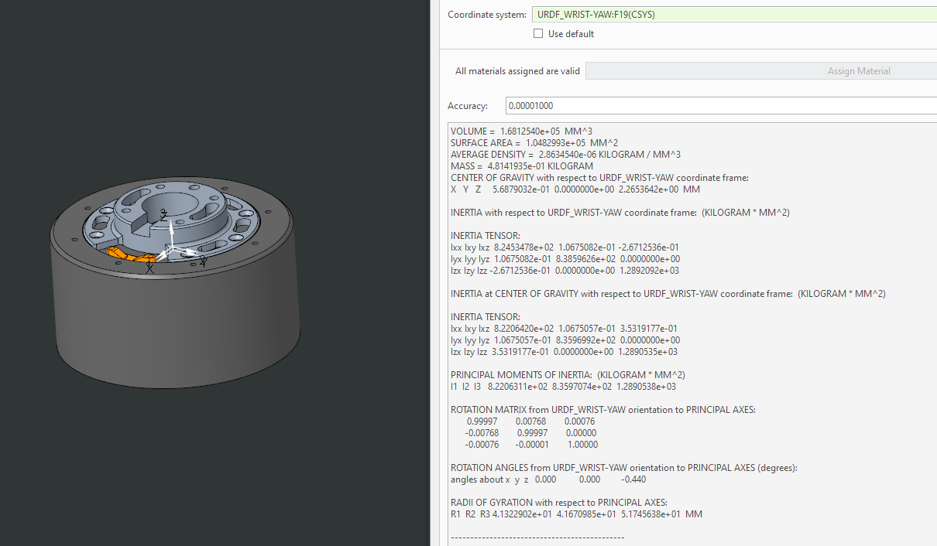

VOLUME = 1.6812540e+05 MM^3

SURFACE AREA = 1.0482993e+05 MM^2

AVERAGE DENSITY = 2.8634540e-06 KILOGRAM / MM^3

MASS = 4.8141935e-01 KILOGRAM

CENTER OF GRAVITY with respect to URDF_WRIST-YAW coordinate frame:

X Y Z 5.6879032e-01 0.0000000e+00 2.2653642e+00 MM

INERTIA with respect to URDF_WRIST-YAW coordinate frame: (KILOGRAM * MM^2)

INERTIA TENSOR:

Ixx Ixy Ixz 8.2453478e+02 1.0675082e-01 -2.6712536e-01

Iyx Iyy Iyz 1.0675082e-01 8.3859626e+02 0.0000000e+00

Izx Izy Izz -2.6712536e-01 0.0000000e+00 1.2892092e+03

INERTIA at CENTER OF GRAVITY with respect to URDF_WRIST-YAW coordinate frame: (KILOGRAM * MM^2)

INERTIA TENSOR:

Ixx Ixy Ixz 8.2206420e+02 1.0675057e-01 3.5319177e-01

Iyx Iyy Iyz 1.0675057e-01 8.3596992e+02 0.0000000e+00

Izx Izy Izz 3.5319177e-01 0.0000000e+00 1.2890535e+03

PRINCIPAL MOMENTS OF INERTIA: (KILOGRAM * MM^2)

I1 I2 I3 8.2206311e+02 8.3597074e+02 1.2890538e+03

ROTATION MATRIX from URDF_WRIST-YAW orientation to PRINCIPAL AXES:

0.99997 0.00768 0.00076

-0.00768 0.99997 0.00000

-0.00076 -0.00001 1.00000

ROTATION ANGLES from URDF_WRIST-YAW orientation to PRINCIPAL AXES (degrees):

angles about x y z 0.000 0.000 -0.440

RADII OF GYRATION with respect to PRINCIPAL AXES:

R1 R2 R3 4.1322902e+01 4.1670985e+01 5.1745638e+01 MM

---------------------------------------------